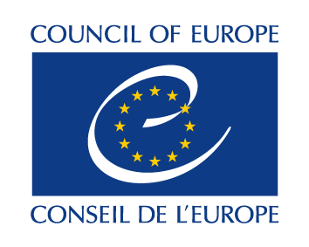
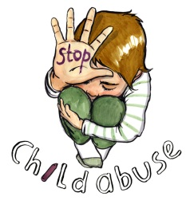

T-ES(2020)18_bil

Working document / Document de travail

15 May 2020/ 15 mai 2020

LANZAROTE COMMITTEE / COMITÉ DE LANZAROTE

Responses to the Covid-19 pandemic to step up the protection of children against sexual exploitation and sexual abuse /
Réponses à la pandémie de Covid-19 pour renforcer la protection des enfants contre l'exploitation et les abus sexuels

Working document to be completed and formatted / Document de travail à compléter et à mettre en forme

Information compiled by the Secretariat of the Lanzarote Committee as submitted so far
in the language it was received /
Informations compilées par le secrétariat du Comité de Lanzarote telles que soumises
jusqu'à présent dans la langue dans laquelle elles ont été reçues
TABLE OF CONTENTS / TABLE DES MATIERES

STATE PARTY INITIATIVES / INITIATIVES DES ÉTATS PARTIES 6
Albania / Albanie 6
Andorra / Andorre 6
Austria / Autriche 6
Azerbaijan / Azerbaïdjan 6
Belgium / Belgique 6
Bosnia and Herzegovina / Bosnie-Herzégovine 11
Bulgaria / Bulgarie 11
Croatia / Croatie 14
Cyprus / Chypre 14
Czech Republic / République tchèque 14
Denmark / Danemark 14
Estonia / Estonie 14
Finland / Finlande 14
France 15
Georgia / Géorgie 19
Germany / Allemagne 19
Greece / Grèce 19
Hungary / Hongrie 19
Iceland/ Islande 19
Italy / Italie 19
Latvia / Lettonie 22
Liechtenstein 22
Lithuania / Lituanie 22
Luxembourg 22
Malta / Malte 22
Republic of Moldova / République de Moldova 22
Monaco 22
Montenegro / Monténégro 22
The Netherlands / Pays-Bas 22
North Macedonia / Macédoine du Nord 23
Norway / Norvège 23
Poland / Pologne 23
Portugal 23
Romania / Roumanie 23
Russian Federation / Fédération de Russie 23
San Marino / Saint-Marin 26
Serbia / Serbie 26
Slovak Republic / République slovaque 27
Slovenia / Slovénie 28
Spain / Espagne 28
Sweden / Suède 28
Switzerland / Suisse 28
Tunisia / Tunisie 29
Turkey / Turquie 29
Ukraine 30
United Kingdom / Royaume-Uni 30
INITIATIVES BY OBSERVERS / INITIATIVES DES OBERVATEURS 31
Hope for Children Cyprus / Hope for Children Chypre 31
eNASCO Belgium / eNASCO Belgique 32
EUROPOL 32
Missing Children Europe 38

Introductory remarks

This working document compiles the information submitted so far by Lanzarote Convention Parties and observers in the Lanzarote Committee in response to the call to share initiatives taken to specifically address child sexual exploitation and abuse during the COVID-19 pandemic. To have a more comprehensive but also focused overview of the situation, the Lanzarote Committee’s Bureau invites the members and observers in the Committee to submit to lanzarote.committee@coe.int any further relevant information and in particular to share their insight on the following questions by 1 June 2020:

- To what extent, if at all, has the threat of child sexual abuse/exploitation changed due to COVID-19? If so:
- Please tell us about whether the level of risk has increased/decreased/remained the same and if possible, specify this with regard to the various types of sexual offences against children (Articles 18-23 of the Convention);
- You may also wish to indicate any emerging trends relating to child sexual abuse/exploitation, as the result of COVID-19, and point at measures taken to address them.

- Did lockdown cause child sexual abuse/exploitation cases (identified/reported) to increase, decrease or stay the same? Please submit data (number of victims/offenders) and highlight what you think may explain the trend.

- Please also tell us whether and how general child safeguarding measures were, or are likely to be, affected by measures taken by governments in response to COVID-19. In addition, highlight any additional, specific measures put in place during lockdown to ensure reporting by victims of child sexual abuse/exploitation as well as to support and assist them, and whether these measures will be maintained even when the lockdown is lifted.

- Finally, please tell us whether children have been duly listened to on decision-making concerning their protection against sexual abuse/exploitation during this period. Please also tell us whether and how children will be involved in decision-making on or assessing the impact of COVID-19 measures in the future.

*******************

Remarques introductives

Ce document de travail compile les informations soumises à ce jour par les parties à la Convention de Lanzarote et les observateurs au Comité de Lanzarote en réponse à l’appel de partager les initiatives prises pour lutter spécifiquement contre l'exploitation et les abus sexuels des enfants pendant la pandémie de COVID-19. Afin d’avoir un aperçu plus complet mais aussi plus ciblé de la situation, le Bureau du Comité de Lanzarote invite les membres et les observateurs du Comité à soumettre à lanzarote.committee@coe.int toute autre information pertinente et, en particulier, à partager leurs points de vue sur les questions suivantes d’ici le 1er juin 2020 :

- Dans quelle mesure, le cas échéant, la menace d’exploitation/d'abus sexuels des enfants a-t-elle changée en raison de la COVID-19 ? Si tel est le cas :
- Veuillez nous indiquer si le niveau de risque a augmenté/diminué/est resté le même et, si possible, précisez ce niveau de risque pour les différents types d'infractions sexuelles contre les enfants (articles 18 à 23 de la Convention) ;
- Vous pouvez également indiquer toute tendance émergente en matière d’exploitation/d'abus sexuels des enfants, résultant de la COVID-19 et signaler les mesures prises pour y faire face.

- Le confinement a-t-il entraîné une augmentation, une diminution ou un maintien des cas d’exploitation/d'abus sexuels d'enfants (identifiés/signalés) ? Veuillez fournir des données (nombre de victimes/délinquants sexuels) et souligner ce qui, selon vous, peut expliquer cette tendance.

- Veuillez également nous indiquer si et comment les mesures générales de protection de l’enfance ont été ou sont susceptibles d'être affectées par les mesures prises par les gouvernements en réponse à la COVID-19. En outre, veuillez mettre en évidence toute mesure supplémentaire et spécifique mise en place pendant le confinement pour garantir le signalement par les victimes d’exploitation/d'abus sexuels d'enfants, ainsi que pour les soutenir et les aider, et si ces mesures seront maintenues même lorsque le confinement sera levé.

- Enfin, veuillez nous indiquer si les enfants ont été dûment écoutés lors de la prise de décisions concernant leur protection contre l’exploitation/les abus sexuels pendant cette période. Veuillez également nous dire si et comment les enfants seront impliqués dans la prise de décision ou l'évaluation de l'impact des mesures COVID-19 à l'avenir.

*******************

STATE PARTY INITIATIVES / INITIATIVES DES ÉTATS PARTIES

Albania / Albanie

No information submitted so far / Aucune information communiquée jusqu'à présent

Andorra / Andorre

No information submitted so far / Aucune information communiquée jusqu'à présent

Austria / Autriche

No information submitted so far / Aucune information communiquée jusqu'à présent

Azerbaijan / Azerbaïdjan

No information submitted so far / Aucune information communiquée jusqu'à présent

Belgium / Belgique

Measures for children and young people (Flemish community)

Coronavirus control measures have a specific impact on children and young people in socially vulnerable positions. The Flemish Government has therefore taken a number of measures to respond to the urgency of information and assistance to children and young people. The starting point of these measures is the best interest of the child and the young person and this in Flanders and Brussels. For instance, it foresees a targeted financial impulse of 100,000 euros for De Ambrassade vzw, for the period from 1 April 2020 up to and including 31 December 2020, to intensify and proactively take up the mission of the youth information platform WAT WAT to centralize information. It also provides 75,000 euros for the period from 1 April 2020 to 31 December 2020 to Awel vzw, 95,000 euros for the period from 1 April 2020 to 31 March 2021 to the Federatie van Tele-Onthaaldiensten, 140. 000 euros for the period from 1 April 2020 to 31 March 2021 to 4 Centres for General Welfare for the reinforcement of the 1712 helpline, and 50,000 euros for the period from 1 April 2020 to 31 March 2021 to the Centre for the Prevention of Suicide for the support of the voluntary work of the Suicide Line 1813.

Chat lines / helplines and assistance

- Direct communication to children, adolescents, parents

- the helpline 1712 distributes a poster and campaign with tips on how to deal with family conflicts
https://www.1712.be/archief/nieuws/id/546/persbericht-coronacrisis-hulplijn-1712-verwacht-toename-van-familiaal-geweld

The helpline 1712 is a helpline for anyone who has questions about violence, about children hurting each other, about adults hurting children, ... For children who are hurting themselves, for children who know that someone else is being injured, for adults who want to help children.

- Action by AWEL (and partners) with a video that was recently launched to encourage children and young people to call the helpline or chat in case of problems.
All children and young people can contact AWEL anonymously about anything that concerns them.

See: https://awel.be/ & https://youtu.be/SeJthazr6KE (movie #noplaatsinuwkot). In case of serious problems, the volunteers can immediately redirect (with the agreement of the child/young person) to more specialised chat lines such as https://www.nupraatikerover.be/ (chatbox Confidentiality Centres Child Abuse).

- Expansion contact hours helplines

- AWEL: It was decided to allocate an additional grant of 75,000 euros to AWEL to strengthen and continue the contingent of volunteers and to train new volunteers now so that in need they immediately can be active.

- Chatbox https://www.nupraatikerover.be/ (chatbox for children about abuse and maltreatment) has drastically extended its opening hours. In the week of 16 March the chat was extra open for 9 hours a week, in the week of 23 March for 15 hours a week.

- Contact hours of the helpline 1712 were also extended.

- Also additional resources for the “suicide helpline” and “Tele-onthaal” were given in order to extend their contact hours. The helpline tele-onthaal is a more general anonymous helpline for all people who have a very big problem or smaller concerns. A volunteer makes time for the people who call, listens, empathizes, thinks along with the person about what he or she says and helps him/her to look for insights, possibilities and solutions. The volunteer will give information about further assistance possibilities if needed.

- Many helplines (e.g. CLB chat for children and their parents - school context) also extended contact hours for online help without additional resources.

- Additional/newly created care offer for very vulnerable children and young people

- Many regional initiatives were taken, among others: Specific help/care offer for vulnerable young people in Bruges: Opening of an emergency shelter for vulnerable children. There is room for 4 children between the ages of 6 and 12 who are in an unsafe home situation and who have nowhere else to go because of the Corona situation.
https://pers.opgroeien.be/de-patio-brugge-opent-noodopvang-kwetsbare-jongeren#

- Reception of victims of domestic violence
Accommodating victims of domestic violence in hotel, also victims of child abuse
https://www.hln.be/de-krant/slachtoffers-huiselijk-geweld-opgevangen-in-hotels~a1510cbf/

- There is an offer under development for the care of sick children who are not taken care of at home.

- Support for residential care that already takes care of children and adolescents because they are in a problematic upbringing situation

- In private residential care facilities of “Opgroeien”, which currently still take care of children who cannot stay at home because of a problematic upbringing situation, staff of “Opgroeien” are brought in to support the working, e.g. due to staff dropping out due to illness.

- There was a call for volunteers to be recruited in order to provide assistance to the facilities where children and young people are staying (via https://www.helpdehelpers.be/ and https://www.vlaanderenvrijwilligt.be/).

- In addition, each organisation is looking for the best way to support/assist currently those children/young people/families (who were taken care of/accompanied before the corona crisis).

- Information for and support of emergency workers

- Clustering of already available online help (see https://iroj.jeugdhulp.be/online-hulpaanbod-covid-19).

- In each region, counsellors can contact the intersectoral information and contact point if they have any questions about youth assistance. They can guide a person through the regional aid offerings that are relevant for children, young people and young adults.

- On SAMvzw, a regularly updated page, all initiatives to support vulnerable young people/families (which also includes international/foreign initiatives/good practices) can be found.
https://www.samvzw.be/nieuws/kwetsbare-mensen-bereiken-tijden-van-corona

The provision of general information for children and young people and general support

- Specific support for vulnerable groups

- Various youth organisations are committed to reach out to their young people. Every day, “KRAS Jeugdwerk” launches a new challenge through their social media channels. Kras is an Antwerp youth work organisation that sets up varied of leisure activities for children and young people in various neighbourhoods of Antwerp.
https://www.krasjeugdwerk.be/

- Various youth movements also launch assignments and activities online, which are also put together by young volunteers. The 'online youth movement' group on Facebook already has more than 40,000 followers.

- "Youth welfare workers" was added by the National Security Council to the ministerial decree on essential professions, at the request of Minister of Youth, Benjamin Dalle.
Together with his colleague Minister Wouter Beke, he is currently working on an action plan that includes concrete measures to strengthen the support for vulnerable youth. To this end, he conducted a survey among youth welfare organisations and brought together involved organisations and representatives of other sectors to give input to the action plan. A task force is currently writing the plan.

- In addition, the preparations for the Youth and Children's Rights Policy Plan are also continuing.

- Targeted offering of information

- The youth information platform WATWAT offers young people relevant information about the corona measures. They do this via a specific section on the website https://www.watwat.be/corona. Various examples are shown on how young people can creatively comply with the measures, adapted to different age categories. These videos are distributed through different channels such as Instagram.

The number of unique visitors to the website increased from 46,964 in February to 82,176 in March. The number of pageviews increased from 128,268 to 189,480. The number of outbound links to other websites increased from 9,351 to 13,487. The number of organically reached accounts on Instagram increased from 22,437 to 40,395. In addition, WATWAT reached 652,357 Instagram accounts through a campaign about the current crisis.

It was decided to award the youth information platform WATWAT a grant of 100,000 euros for:
- the coordinated collection, bundling and distribution of truthful, accurate and up-to-date information that can be found on various channels, with a view to a targeted bundling of youth information, improving mental well-being and picking up fake news, deep fakes and conspiracy theories;
- rolling out a collaboration with influencers in Flanders;
- the targeted use of media space that particularly reaches the target group of vulnerable children and young people.

- The 'NWS NWS' Instagram account of the Flemish television channel VRT focuses on a young audience and regularly involves young people in positive stories, with which they contribute to the society on their own initiative. From making face masks to writing postcards to the grandparents.

- The information on coronavirus measures is now also available in several languages and in “simple language Dutch”.

It concerns measures and FAQs for citizens: about hygiene, social distancing and the restrictions in public life. The Flemish and federal authorities use the same translations and retranslations.

You can find the translations on the following websites:
- https://www.integratie-inburgering.be/corona-meertalige-info
- www.info-coronavirus.be/translation

The Flemish administration collects multilingual information about the coronavirus: posters with preventive measures, fact sheets with basic information and links to useful websites. They systematically supplement them.
https://www.integratie-inburgering.be/corona-meertalige-info

Even during the corona crisis, newcomers continue to follow the social orientation course. Nine out of ten students now do so digitally.

The 10 percent who are not reached by digital means were informed about the corona guidelines by telephone and will be picked up during the next courses. They did not have sufficient digital tools at their disposal, such as a laptop or smartphone.

Specific government information for the culture, youth and media sectors:
https://cjsm.be/informatie-covid-19

Measures concerning French and German communities

- Déclaration par Vice-Présidente et Ministre de l’Enfance, de la Santé, de la Culture,des Médias et des Droits des Femmes, Bénédicte Linard

- Voir aussi, le site de Yakapa qui recense des vidéos ressources destinées aux professionnels sur de très nombreux sujets concernant les enfants pendant la pandémie Covid-19, notamment la violence conjugale.

Exemples :
- En contexte Covid-19, comment protéger les enfants exposés à la violence conjugale ?
- Comment remettre du tiers dans les situations à risques de maltraitance ?
- Comment soutenir l'enfant en contexte de confinement familial impacté par de la violence conjugale ?
- L'aide du réseau familial/amical/professionnel en cas de violences entre parents en contexte de confinement

Child Focus

- Child Focus a publié un Message en période de confinement
- Child Focus a publié une déclaration : COVID-19 – Garder les enfants heureux et en sécurité en ligne

Better internet for Kids

- Better Internet for Kids, March edition of the BIK bulletin: Staying safe online during the coronavirus pandemic

Bosnia and Herzegovina / Bosnie-Herzégovine

No information submitted so far / Aucune information communiquée jusqu'à présent

Bulgaria / Bulgarie

- The existing National Telephone Hot Line for Children 116-111 is available to all children and their families, to whom psychologists listen, support, direct callers on all matters of concern to them, and in the meantime, at child risk data, contact immediately the authorities for the protection of the child, depending on the scope, for investigation and action and protection measures, with the State Agency for Child Protection monitoring the measures taken until the risk for the child is eliminated.

- On March 17, 2020, in implementation of Art. 32, para. 6 of the Radio and Television Act, Council for Electronic Media, State Agency for Child Protection, Association of Bulgarian Radio and Television Operators, Bulgarian National Television and the Bulgarian National Radio undersigned 2020 Agreement for the Protection of Children from Content, which is unpleasant or creates a risk of damaging physical, mental, moral and/or social development.

In relation with the introduction of State of Emergency in the Republic of Bulgaria of March 13, 2020, as a precautionary measure against the spread of the COVID-19 coronavirus, a decision was made to be signed in absence. By signing the Agreement, the Parties once again declare their readiness to join forces and in partnership to work towards the implementation of Criteria for Assessing Content that is disadvantageous or creates a risk of impairment of the physical, mental, moral and/or social development of children, adopted in 2011 and amended in 2017 to protect the children's audience, and the rights and interests of children.

- In view of the spread and the danger of COVID-19, the State Agency for Child Protection (SACP) has created an online service which is a new opportunity for all - children and adults, who need to ask or share their emotions and anxieties. The created section of the Agency's website is another opportunity for anyone who is looking for an answer to an important question, related to an unknown and new situation. The online service is supported by psychologists, whose aim is to help people feel more relaxed while abiding the imposed restrictions to stay at home and to protect themselves from the coronavirus.

Feedback Form has been developed on the Agency's website and anyone can use it to submit their email and describe in the text box the issue that is of concern. The person receives a response from a consultant, a professional in crisis situations, on their email. Some of the questions asked are posted on the site for the benefit of others, while maintaining the anonymity of everyone.

The practice of alerting, when a child is at risk for his or her health or life, to the local Child Protection Departments, police authorities and others, continues. The SACP can provide psychological support through a conference call, as well as in case of urgent need to send a team on site, while taking the appropriate precautionary measures in the state of an emergency.

- In connection with the state of emergency in Bulgaria, in March 2020 the Chairperson of the SACP addressed all mayors of municipalities in Bulgaria, as child protection bodies, with an appeal for increased commitment to all children, including those who are placed in residential care. The chairperson stressed the need for increased commitment in compliance with World Health Organization measures for high personal hygiene and disinfection of facilities in social services for children, managed by municipalities.

In a letter, addressed to all 28 districts in the country, the chairperson of the SACP emphasized the concern for the health and well-being of all Bulgarian children, who are currently undergoing social exclusion because of the coronavirus. And while for adults, the motivation for adhering to and implementing the measures imposed by the National Crisis Staff in Bulgaria is high, for children this becomes even more challenging with each passing day.

The social isolation for children at the moment can be a cause for increased emotionality, depression and anxiety. In their interest, the SACP offered specific channels of assistance through counselling and psychological support. The Agency provided materials to health and safety councils, proposals for active and fun leisure activities, as well as opportunities to seek information and support when needed, to all mayors of municipalities. It has also been proposed to disseminate guidance to residential childcare services, where the children are more vulnerable.

- In April 2020, the SACP updated the control measures for the observance of the rights of the child and started to conduct remote online checks. This affects inspections at all schools, kindergartens and crèches, personal development support centres, healthcare facilities, Social Assistance Directorates and all child welfare providers. The new method of verification is done through the exchange of documents in the secure electronic service system, as well as the transfer of materials through encrypted files.

The Agency has also created conditions for video conferencing, depending on the capabilities of those being interviewed. On the basis of the results of remote online checks, instructions can be issued, in the case of an established violation, with a specified deadline for implementation, as well as methodological instructions and/or recommendations. Other competent authorities will be notified of their summaries.

This manner of work by the SACP is required by the recommendations of the National Operational Headquarters against the proliferation and danger of COVID-19. It will also be used in the future in case of an emergency situation. The first online inspection was made in the Social Assistance Directorate at the discretion of the District Prosecutor's Office related to a case of a child, being removed and placed in a foster family.

- In support of the children, SACP posted on its Facebook page a message from a member of the Children's Council, which seeks to inspire the faith and courage of children and their parents, to motivate them to strictly abide by the rules to limit the spread of the virus, as well as to support each other emotionally and to be hopeful, that we will handle this challenge, when we are united and we follow the rules.

- The SACP has made an appeal to parents, who have had a separation and parental rights dispute or are in conflict, in the context of regulated child-parent contacts, posted on the Agency's website, urging them to be patient so as not to exert pressure, and actively to communicate with their children using different forms for contact: Skype, phone, Viber, Messenger and others.

- To date, the SACP is actively involved in the process of making and summarizing proposals from employees for new, innovative and responsive proposals to support the children and their parents, for launching initiatives and activities to support even more Bulgarian citizens.

- UNICEF Bulgaria has translated and promoted information material from WHO, UNICEF and other international organizations targeting parents, professionals working with children and carers, as well as children and young people in difficult situations.

- The Steps Together program of UNICEF Bulgaria and the Ministry of Education and Science envisages the development and implementation of a comprehensive school program for a safe school environment and prevention of bullying and violence in the next three years, with the active participation of schools, building on good practices and existing experience in the country. The purpose of the program is to respond to the real needs and context of the different settlements, in which it will be piloted and implemented, as well as to ensure its sustainability and subsequent implementation throughout the country.

In addition to experience from other countries, practices that have been/or already exist in Bulgarian schools will be taken into account. Students will be equal participants in the process of change - the phenomenon of school violence affects children most directly. Therefore, they know best what the problem is, and what its potential solutions may be. It is envisaged that parents will be involved - it is crucial for parents to partner with their child, and with the entire school community in the school life, not just when a problem arises and is resolved. This helps to be created a culture of belonging and trust for all participants in the educational process.

- Parents' Tips - How to Talk to Your Kids about COVID-19, as well as Key Messages and Measures Against COVID-19 can be found on the UNICEF website.

- NGOs provide free online services to citizens. Teams provide psychological support; crisis intervention for needy children and adults, as well as mediation for liaison with other services and support.

- In connection with the possible increase in domestic violence cases from April 2020, it is possible to report domestic violence via smartphone at Pomogni.net. A button is placed in the application, which is activated when needed. After that information is automatically sent to Number 112 and the Animus Association Foundation, including the victim's location, names, and cell phone.

Croatia / Croatie

Considering that organizations worldwide have warned of a "epidemic of abuse" that could result from physical distancing measures during the COVID-19 pandemic, the Ministry of the Interior of the Republic of Croatia, the City of Zagreb's Child and Youth Protection Clinic and the Degordian Agency are jointly conducting a campaign "Behind the door". At the centre of the campaign is an imaginary girl, named Mia, who lives with the abusive household member "behind closed doors". The campaign aims to make citizens aware of the necessity and importance of reporting violence in their surroundings at all times, and especially in the current situation when children and young people, as especially vulnerable groups, are reduced in their ability to physically distance themselves from the abuser, or to confide in other adults of trust - teachers, doctors, psychologists. Please note that the campaign has also been recognized by international institutions and agencies such as Europol, which highlight it as an example of good practice, and by the European Crime Prevention Network (EUCPN), which has also included this campaign on its website: https://eucpn.org/document/behind-the-door

We would also like to emphasize that, in the context of the measures of social exclusion taken to protect against COVID-19, the Police Directorate particularly takes into account the possible escalation of violence against children and the prevention of violence against children is one of the priorities of the police. Therefore, through campaigns like this, it further appeals to citizens that, when they perceive a risk or threat to the safety of a child or vulnerable family members, they respond and report to the police their knowledge or doubts. The police act promptly on reports or information about the exposure of children to abuse and uses victim protection mechanisms.

The aforesaid campaign is also available on the website of the Ministry of the Interior: https://policija.gov.hr/vijesti/iza-ovih-vrata-zivi-mia/4591

Cyprus / Chypre

No information submitted so far / Aucune information communiquée jusqu'à présent

Czech Republic / République tchèque

No information submitted so far / Aucune information communiquée jusqu'à présent

Denmark / Danemark

No information submitted so far / Aucune information communiquée jusqu'à présent

Estonia / Estonie

No information submitted so far / Aucune information communiquée jusqu'à présent

Finland / Finlande

No information submitted so far / Aucune information communiquée jusqu'à présent

France

Dans le contexte de crise sanitaire liée à la propagation du Covid-19, et plus particulièrement durant la période de confinement, la protection des enfants en danger, y compris les enfants victimes d'exploitation et d'abus sexuels, est de la plus haute importance. Tous les membres et observateurs du Comité de Lanzarote ont été invités à partager les initiatives prises.

Les initiatives prises par la France peuvent être développées comme suit :

Initiatives prises pour lutter contre les violences et abus sexuels faits aux enfants

S’agissant des initiatives prises afin d’améliorer la protection des enfants contre les abus sexuels pendant la crise sanitaire, la circulaire du 25 mars 2020 de présentation des dispositions applicables pendant l’état d’urgence sanitaire et relative au traitement des infractions commises pendant l’épidémie de Covid-19 a rappelé que la lutte contre les violences intrafamiliales relevait d’un traitement prioritaire en temps de crise, malgré les plans de continuité d’activité mis en œuvre dans les juridictions.

Des instructions précises ont été données par les procureurs aux services d’enquête afin d’exercer une vigilance accrue à l’égard des familles, dans le traitement des signalements et les appels à police-secours.

Enfin, une plateforme nationale de recherche de places d’hébergement pour les auteurs de violences intrafamiliales évincés du domicile par décision judiciaire est opérationnelle depuis le 6 avril, joignable par mail sur l’ensemble du territoire national, y compris les ressorts ultramarins, afin de pallier les difficultés rencontrées par les structures d’hébergement en raison de la crise sanitaire.

Enfin, le Gouvernement a largement diffusé des informations selon lesquelles les pharmacies pourraient être un lieu de signalement des violences et abus des victimes de violences conjugales et des enfants maltraités.

Rôle de détection de la hotline 119

Consciente que pendant cette période de confinement, les institutions telles que les écoles, crèches, centres de loisirs ne peuvent plus jouer leur rôle de détection, la continuité de la cellule de recueil des informations préoccupantes (CRIP), en lien avec la hotline 119, est une priorité.

Une campagne de communication nationale a donc été diffusée à la télévision du 30 mars au 6 avril et à la radio du 2 au 11 avril, concernant la violence contre les enfants et la promotion de la hotline 119, numéro d’appel d’urgence demeurant opérationnel pendant la crise.

Depuis le 24 mars 2020, l'équipe de la hotline 119 s'est agrandie avec 27 conseillers à tour de rôle 24/7. Les conseillers sont entièrement dédiés aux appels provenant d'enfants afin d'éviter tout retard.

Continuité des audiences devant le juge des enfants

Dès la mise en place de l'état d’urgence sanitaire et des restrictions aux déplacements, le gouvernement français a décidé de réduire le nombre d’audiences afin de limiter la propagation du virus. Cependant, l'activité juridictionnelle liée aux cas urgents est maintenue. La protection des mineurs en danger et la continuité de la protection des mineurs faisant suite à une décision judiciaire sont une priorité du Gouvernement pendant la période de confinement. Ainsi, il est toujours possible de rendre compte au procureur ou au juge des enfants d’une situation dangereuse concernant un mineur et de demander son placement urgent dans un environnement sûr. Les ordonnances de placement provisoires continuent ainsi d’être prises par les parquets, lorsque la situation de danger et l’urgence le justifient, même si en raison des restrictions sanitaires et de la fermeture de certains lieux d’accueil collectif, des solutions familiales alternatives sont recherchées en priorité.

La possibilité pour un mineur de saisir le juge des enfants est également maintenue et des audiences ont lieu concernant ces affaires.

Les mesures en cours prises par le juge des enfants, et notamment celles relatives aux placements de mineurs, peuvent être prorogées automatiquement jusqu'à deux mois après la fin de l'état d'urgence sanitaire afin de ne pas interrompre les suivis déjà mis en œuvre.

En outre, des instructions ont été données aux services éducatifs afin qu’ils puissent rester en contact avec les familles des mineurs, notamment par téléphone.

Enfin, même si les tribunaux restent ouverts à ceux qui ont été convoqués, des permanences téléphoniques sont mises en place et le contact par e-mail est toujours possible dans tous les tribunaux pour enfants.

Soutien aux établissements du secteur associatif habilité

Le ministère de la Justice soutient également les établissements du secteur associatif habilité (SAH) :
- en maintenant le financement d'établissements et de services dont les seules ressources proviennent de la protection de la jeunesse (enquête pénale et
assistance éducative) en cas de réduction ou de suspension d'activité due à l'épidémie de Covid-19;
- en finançant les placements dans les établissements à double autorisation (Etat et départements) sur la base d'une durée déterminée et non d'une activité réelle, afin d'éviter de pénaliser les établissements en cas de retour des enfants dans leur famille.
- en prenant en compte les remplacements rendus nécessaires par l'impossibilité pour certains professionnels (notamment ayant des enfants) de retourner à leurs postes de travail.
- en reportant le délai du dépôt des comptes administratifs jusqu'au 30 juin 2020.

Continuité des missions de protection de l’enfance

Le secrétaire d'État chargé de la protection de l'enfance a adressé une lettre le 21 mars 2020 à tous les présidents des conseils départementaux, insistant sur la nécessité d'assurer la continuité des missions de protection de l'enfance. En outre, le Secrétaire d'État souligne la situation des mineurs non accompagnés, qui doivent continuer à être hébergés, car ne pouvant être déplacés pendant la période de confinement et dont la protection ne doit pas être interrompue pendant la crise.

Par ailleurs, deux fiches et recommandations ont été publiées le 24 mars 2020 sur le site du ministère de la Solidarité et de la Santé : l'une destinée aux structures des services de protection de l'enfance, en liaison avec le Service judiciaire de la protection de la jeunesse, l'autre adressée aux assistants sociaux. Un troisième volet de l'aide judiciaire à la gestion des budgets familiaux, élaboré en concertation avec le Service judiciaire de la protection de la jeunesse, est en cours de préparation.

Des dérogations ont également été votées pour autoriser les établissements sociaux et médico-sociaux à être dispensés de fournir des services en dehors de leur zone d'agrément.

Actions des services de la police et de la gendarmerie nationales

La crise sanitaire liée à la pandémie du COVID-19 impose des restrictions de circulation qui génèrent une promiscuité accrue au sein des cellules familiales. Ces contraintes exceptionnelles, qui modifient profondément les modes de vie et les comportements, sont susceptibles d'accentuer les déviances conduisant à certains abus de nature sexuelle sur enfants et à éventuellement accentuer une exploitation déjà existante. Concomitamment, les moyens d'alerte et de signalement habituellement offerts aux jeunes victimes sont réduits voire annihilés (comme le signalement via le système éducatif). C'est dans ce cadre que le comité de Lanzarote (Comité des parties à la Convention sur la protection des enfants contre l'exploitation et les abus sexuels) demande à la France de communiquer sur les moyens pris pour la protection des enfants contre l'exploitation et les abus sexuels en temps de pandémie COVID-19.

I- Plusieurs constats ont été effectués par les forces de sécurité intérieure pendant cette période de confinement, notamment :

- S'agissant de la pédopornographie en ligne sur les réseaux P2P (pear to pear) : il est constaté une augmentation des connexions et des téléchargements sans qu'elles ne puissent quant à présent être chiffrées. Il apparait clairement que des IP qui avaient disparu du champ des outils de veille depuis quelques mois reviennent et téléchargent à nouveau, et que les IP "habituelles" sont connectées plus longtemps, afin de récupérer plus de matériel.

- S'agissant du clearnet : Il n'existe pour le moment aucun changement significatif. Un nouveau jeu est toutefois apparu dans le champ de surveillance : le MSP (Movie Star Planet). Il s'agit d'un jeu social qui permet de devenir une star virtuelle. La limite d'âge pour créer un profil est de 12 ans. Le jeu permet d'évoluer dans un monde où l'enfant peut interagir avec des personnes et rejoindre des "place to be" sous forme de "tchat" et se faire des amis. Beaucoup de prédateurs sexuels qui fréquentent Rindexxx (Darknet) se servent de ce jeu en ligne pour obtenir les Snap de jeunes filles âgées de 14 à 18 ans. Ce phénomène reste donc très surveillé par les services

- S'agissant du darknet : Les "chats" sont encombrés. Il a été constaté l'apparition de nouveaux membres depuis le confinement ou de personnes qui n'étaient pas des habitués, donc un changement significatif dans les comportements. Concernant le contenu des échanges, de nombreux internautes indiquent avoir maintenant la possibilité de "jouer" à domicile car en présence de leurs enfants, mais aucune diffusion de production personnelle n'a été jusqu'à maintenant constatée. Il n'a pas été constaté de message révélant des abus sexuels jusqu'à aujourd'hui, mais l'Office Central pour la Répression des Violences aux Personnes (OCRVP) reste très mobilisé pour surveiller ces évolutions liées au confinement.

II- Des mesures ont été prises par les forces de sécurité intérieure pour renforcer les dispositifs existants

- Consolidation du dispositif d'information et de signalement via la Brigade Numérique et le portail des Violences Sexuelles et Sexistes (effectif multiplié par 5, 100 personnels pendant la crise) ;
- Entretien de contacts réguliers avec le SNATED (Service National d'Accueil Téléphonique de l'Enfance en Danger -- 119 Allô enfance en danger) ;

Ces contacts visent à maintenir un lien étroit entre la plateforme 119 et les centres d’opérations et de renseignements de la gendarmerie (CORG) en cas de situation d'urgence

- Prise de contact, physiquement ou téléphoniquement, avec les victimes ou ex-victimes de violences intrafamiliales pendant la période de confinement.
- Orientation des actions du réseau CyberGend sur les phénomènes de délinquances en lien avec la crise COVID-19.
Face à l'augmentation des usages d'internet en cette période de confinement, une attention particulière est portée par les enquêteurs sous pseudonyme à la protection des personnes vulnérables et notamment aux mineurs qui sont massivement connectés dans le cadre de l'enseignement à distance. Le Centre National d'Analyse des Images Pédopornographiques (CNAIP) du C3N est pleinement intégré à cette manœuvre. Ces premières directives ont été complétées par des directives opérationnelles transmises aux unités insistant sur la veille active des réseaux sociaux et des différents darknets pour prévenir, détecter et traiter les infractions commises au préjudice des personnes les plus vulnérables.
- Mise à disposition du public de flyers d'information visant à alerter les parents sur l'usage par les enfants des smartphones et des risques liés à l'utilisation par eux d'Internet.

Dans ces flyers, sont rappelés les principaux conseils pour contrôler l'activité des enfants et leur permettre une navigation sécurisée. De la même manière, les parents sont sensibilisés aux risques d'internet via ses réseaux sociaux, avec notamment par la création d'une infographie qui traite notamment de la thématique des dangers sexuels (nude, sexting, etc.).

- Concernant le monde des jeux, la Direction Centrale de la Police Judiciaire, et notamment l’Office central pour la répression des violences aux personnes (OCRVP), participent à l'initiative de l'association "L'enfant bleu", qui, avec l'appui de l'agence Havas a décidé de créer un personnage dédié pour le jeu Fortnite (jeu vidéo de combat en ligne). Les enfants qui se sentent en danger pourront l'ajouter dans leur jeu discrètement afin de pouvoir donner l'alerte.

Georgia / Géorgie

No information submitted so far / Aucune information communiquée jusqu'à présent

Germany / Allemagne

No information submitted so far / Aucune information communiquée jusqu'à présent

Greece / Grèce

No information submitted so far / Aucune information communiquée jusqu'à présent

Hungary / Hongrie

No information submitted so far / Aucune information communiquée jusqu'à présent

Iceland/ Islande

No information submitted so far / Aucune information communiquée jusqu'à présent

Italy / Italie

Extraordinary leave for parents and babysitting bonus
As a consequence of the spread of the Covid-19 virus all over the country and considering the subsequent temporary suspension of the provision of child education services and teaching activities in all Italian schools, art. 23 of Decree Law No. 18 of 17 March 2020 (the so-called Cura Italia Decree) introduced an extraordinary leave and bonus for parents, with the aim of supporting them during the period of temporary closure of school activities.
Indeed, starting from 5 March 2020, parents working in the private sector with children up to 12 years of age have access to a specific 15-day leave covering 50% of the salary. The leave can be enjoyed by both parents alternatively and only if no other income support measures apply for the family members.
Age limits do not apply to children with serious disability certified under Law No. 104/1992.
Furthermore, starting from 17 March 2020, as an alternative to the Extraordinary leave, private sector working parents can choose to receive a specific bonus for the purchase of babysitting services amounting to 600 euros. For parents working in the public and private accredited health sector, as well as for the police and the defense personnel employed with anti-Covid tasks, the babysitting voucher is increased to totally 1,000 euros.
The above-mentioned measures can be requested for also by foster parents.

Extension of paid leaves for people assisting persons with disabilities
Among the numerous measures taken to support families during the Covid emergency, the abovementioned Decree Law has increased the already existing monthly paid leave for working people assisting a person or relative with disability (pursuant to Law No. 104/1992) from 3 to 15 days for March and April 2020.

Family Card
On 18 March 2020, the new Family Card was lunched by the Department for Family Policies of the Presidency of the Council of Ministers. The Card allows families with 3 children under 26 years of age to access discounts and price reductions on goods and services offered by the companies participating in the initiative and listed in the online portal specifically set up by the Department (https://www.cartafamiglia.gov.it/cartafamiglia/). With the entry into force of Decree Law No.9 of 2 March 2020, the Family Card has been extended to all families with one child living in the Italian territory, with a view to providing additional support to families during the current virus crisis.

Experts’ groups on family/children and Covid
Within the framework of the activities carried out by the national Observatory for Childhood and Adolescence (established within the Presidency of the Council of Ministers – Department for Family Policies), on 8 April 2020 the proposal was made to establish a specific Working Group of experts for the assessment of the current health emergency’s impact on children and the identification of actions and strategies on the topic to be proposed to the Government.
Also within the framework of the National Observatory on Family, a special experts’ Working Group is being established with a view to assessing the impact of Covid emergency on demography and family choices. The start of the Working Group’s activities will be announced on 28 April 2020 during the presentation of a survey carried out by the Toniolo Institute on the effects of the pandemic on youth’s change of habits and life projects.

Anti-Wastage donations
With the aim of contributing to overcome the loneliness experienced by hospitalized children and elderly people, as well as by children and their families staying home in compliance with the lockdown measures currently in force in Italy, and with a view to providing people with more educational and cultural opportunities while in the hospitals and at home, the Minister for Equal Opportunities and Family called upon the main IT and toy-selling companies operating in Italy to donate them electronic, IT, educational and play materials (toys, personal computers, tablets, e-readers, etc.) in line with the anti-wastage provisions extended by art. 31 of Decree Law No. 9 of 2 March 2020.

The “#CiStoDentro” (#IAmIn) initiative
The “#CiStoDentro” (#IAmIn) project is the new initiative launched by the Minister for Equal Opportunities and Family to provide all parents with a tool for experimenting new ways to play with their children at home during the current lockdown. The initiative is available on the website of the Department for Family Policies (http://famiglia.governo.it/ci-sto-dentro/) and includes several sections, such as 1) information on Coronavirus; 2) the possibility to send a letter to the Minister; 3) pieces of advice on new games to be played at home; 3) suggestions on books to read; and 4) a photo gallery.

Toll-free number for older people
Upon request of the Minister for Equal Opportunities and Family and in collaboration with the Ministry of Health and the Presidency of the Council of Ministers - Department of Civil Protection, a specific toll-free number providing psychological support for the most vulnerable people (especially older people) in the Covid emergency situation is currently in the process of being activated.

“Educhiamo” (Let’s Educate) Call for Proposals
The Department for Family Policies is elaborating a public Call for proposals for the financing of non-formal and informal education projects for the empowerment of children and youth, with a view to allowing them to acquire knowledge and abilities that will contribute to the development of their potential as active and responsible citizens and promote their commitment towards their society, while respecting differences. The Call will be aimed at promoting such activities to accelerate the recovery of the society after the end of the coronavirus global emergency, in collaboration with civil society organizations and local bodies. The total amount that will be allocated should be 30 million euros and will fund projects on children’s and youth’s empowerment, intercultural exchange, intergenerational dialogue, non-discrimination and equality, inclusion of disadvantaged people and persons with disabilities, promotion of healthy lifestyles among children and youth, environmental protection and sustainable development, appreciation of local cultural heritage and respectful use of social media.

“Giochiamo” (Let’s play) Call for Proposals
This initiative will provide financings for projects envisaging play activities for children aimed at finding alternative and creative solutions for them to enjoy their rights to rest, free time, recreational, cultural and artistic activities during Stage 2 of the Covid emergency. The total amount allocated for the Call will be equal to 5 million euros. The abovementioned solutions could envisage, inter alia, the carrying out of outdoor play activities for children under adults’ supervision, as well as online and offline child-friendly cultural and artistic activities, all in line with the social distancing protocols. The funded actions will also be aimed at supporting children and their families whose vulnerable conditions have worsened after the Covid outbreak, such as families with disabled children and families living in economic and educational poverty or in social marginalization.

Support and assistance for older people and families with children by voluntary workers
The Minister for Family Policies and the Minister for Youth Policies and Sport have signed a Memorandum of Understanding aimed at financing hourly civilian service projects specifically envisaging assistance and support activities for older people to be implemented during Stage 2 of the Covid crisis.

Joint letter to EU Commissioner Schmit
A joint letter signed by the Italian Minister for Equal Opportunities and Family, Prof. Elena Bonetti, the French Secretary of State for Child Protection, Mr Adrien Taquet, and the German State Secretary at the Federal Ministry of Family Affairs, Senior Citizens, Women and Youth, Ms. Juliane Seifert, has been sent to the European Commissioner for Jobs and Social Rights, Nicolas Schmit. The initiative is aimed at avoiding that the condition of children living in poverty and social exclusion in the EU is further worsened by the global health emergency the Union is facing and that will have heavy economic and social consequences especially on children and youth. The letter underlines the importance of a stronger, prompt, and coordinated response of the European Commission and the EU Member States for combating child poverty, with a view to ensuring the most vulnerable children the best possible growth, including through economic support measures such as the Child Guarantee for vulnerable children.

Latvia / Lettonie

No information submitted so far / Aucune information communiquée jusqu'à présent

Liechtenstein

No information submitted so far / Aucune information communiquée jusqu'à présent

Lithuania / Lituanie

No information submitted so far / Aucune information communiquée jusqu'à présent

Luxembourg

No information submitted so far / Aucune information communiquée jusqu'à présent

Malta / Malte

No information submitted so far / Aucune information communiquée jusqu'à présent

Republic of Moldova / République de Moldova

No information submitted so far / Aucune information communiquée jusqu'à présent

Monaco

No information submitted so far / Aucune information communiquée jusqu'à présent

Montenegro / Monténégro

No information submitted so far / Aucune information communiquée jusqu'à présent

The Netherlands / Pays-Bas

No information submitted so far / Aucune information communiquée jusqu'à présent

North Macedonia / Macédoine du Nord

No information submitted so far / Aucune information communiquée jusqu'à présent

Norway / Norvège

No information submitted so far / Aucune information communiquée jusqu'à présent

Poland / Pologne

No information submitted so far / Aucune information communiquée jusqu'à présent

Portugal

The Portuguese Ministry of Justice (Directorate-General for Justice Policy, briefly referred to as DGPJ) has:

- Translated the Declaration;

- Selected seven strategic partners, including professional bodies (medical doctors and psychologists), as well as a technological Consortium which also includes the private sector;

- Sent the translated version to those partners, with a special reference to its specific demands, asking them to inform us about the measures taken;

- Notified these selected partners about the information provided by the Council of Europe on the effects of COVID-19 on children's rights, which can be found at https://www.coe.int/en/web/children/-/children-may-be-confined-but-their-rights-are-not- and https://www.coe.int/en/web/children/covid-19 ;

- Published the original Declaration on DGPJ’ site https://dgpj.justica.gov.pt/ (15th April) and DGPJ’s Facebook https://www.facebook.com/DGPJ-Direção-Geral-da-Política-de-Justiça-195351910489295/ (8th April).

Complete information about the measures taken will follow.

Romania / Roumanie

No information submitted so far / Aucune information communiquée jusqu'à présent

Russian Federation / Fédération de Russie

The Russian Federation has set forth comprehensive measures to protect and support children and adolescents in times of the COVID-19 pandemic.

It is crucial to emphasize that Russian authorities undertake counteraction and preventive activities against child’s sexual abuse as part of far-reaching steps aiming at comprehensive protection of children, their physical health, psychological support of minors and their parents.

In the Russian Federation complex interservice work including normative, administrative, practical, organizational and law measures was organized to ensure complex protection of minors during the epidemic.

The Ministry of Education of the Russian Federation issued Order No. 104 dated March, 17th, 2020, “On organization of educational activities at institutions that run educational programs of primary, basic, general and secondary general education, educational programs of secondary professional education, further general and professional educational programs, within the spread of new coronavirus infection on the territory of the Russian Federation”: https://docs.edu.gov.ru/document/750dd535d2c38b2a15cd47c9ea44086e/download/2751/

The order outlines a strong requirement to ensure educational programs full-scale implementation in digital environment (clause 1.3.) as well as emphasizes a critical necessity to follow up educative tasks that aim at personality’s development, socialization of children based on socio-cultural, spiritual and moral values, norms of behaviour in the interests of the man, family, society, and nation (clause 1.4.).

In addition, on April 1st, 2020, the Ministry of Education of the Russian Federation launched a series of expert consultations for parents on children’s online activities in the context of coronavirus and self-isolation regime, which involves the use of distant technologies for education and socialization: Children and the Web: 5 Parental Myths about the Internet
https://docs.edu.gov.ru/document/40e44943fa007083b068081b8394e114/

Recommendations were elaborated in order to help parents protect children from bullying, sexual abuse and pressure on the Web.

Russian regions have received guidelines from the Ministry on temporary transfer of children from institutions for orphans and children left without parental care to the Russian citizens’ families due to unfavourable sanitary and epidemiological situation caused by the spread of coronavirus infection COVID-19 and with the aim to ensure children’s safety and security.

The Russian Federal Service for Surveillance on Consumer Rights Protection and Human Wellbeing (Rospotrebnadzor) has developed special recommendations for parents to help protect from coronavirus. These recommendations have been published on the agency website:
https://www.rospotrebnadzor.ru/about/info/news/news_details.php?ELEMENT_ID=14129

In particular, it is recommended to limit children’s contacts not only with peers but even more with outsiders, to ensure compliance with the self-isolation regime.

At the same time distant learning has been provided not only for educational but also for awareness-raising and outreach activities (preparation for school exams, virtual excursions, performances, etc.).

Such activities are implemented across the Russian Federation public entities, see, for instance, the data related to the Moscow region:
https://mosreg.ru/sobytiya/obzory/obrazovanie-v-podmoskove-v-period-samoizolyacii-onlain-aktivnosti-i-dezhurnye-gruppy

In the framework of specific measures of state social policy for those children whose parents continue to work during this period, standby groups operate in kindergartens and elementary schools. See, for example, the following information:
Yekaterinburg https://www.youtube.com/watch?v=sJBZ2YIfzRU
Khanty-Mansiysk Autonomous Okrug – Ugra https://www.youtube.com/watch?v=yXmBWKTf9Xs

In terms of law enforcement, the Ministry of Internal Affairs of the Russian Federation pays special attention to proactive measures of protection and preventive work with minors.

As part of scientific and applied activities of the relevant specialized organizations, recommendations are developed for parents on psychological aspects of interaction with children in conditions of self-isolation. See, for instance, an example from Udmurtia:
http://xn-80aikabba4avndeqflcz9p.xn-p1ai/roditeli-poderzhite-podrostkov-v-usloviyax-samoizolyacii/

A range of all-Russian webinars for parents has been launched. For instance, the Federal State Budgetary Institution Center for the Protection of the Rights and Interests of Children (Moscow) has set forth following resources: Games and toys for young children; Nature of key psychological problems. Model of parenting and parental mistakes; Effective organization of teenager’s educational activities through preparation for exams at home; Features of adolescence in terms of psychology, sociology, and ethology: adolescent deviance; Eight rules for safe communication with adolescents: how parents respond to “difficult” child behaviour; How to organize joint play activities of parents with children from 1 to 13 years old at their apartments; Dialogue of a teenager with parents: simple conversation on complex topics: https://fcprc.ru/news/vebinary-dlya-pedagogov-spetsialistov-roditelej-i-podrostkov/

Regional experience can be estimated with regard to Kemerovo region as an example.

Despite the unfavourable epidemiological situation, checks on complaints and reports of crimes against minors in the region are carried out within the time period specified by the legislation of the Russian Federation and in the presence of both legal representatives and specialists of the forensic psychologists department of the state educational organization Kuzbass Regional Center for Psychological, Pedagogical, Medical and Social Assistance “Health and Personal Development” (hereinafter referred to as the Center).

It should be noted that the call of the minor and his/her legal representatives takes place only if it does not affect their state of health, and interrogation is an urgent investigative action.

Protection of children’s interests is carried out due to a well-functioning system of interagency cooperation among the Center, police departments, employees of the juvenile affairs department, investigators of the Investigative Committee for Kemerovo region.

Along with minors’ support during investigative actions, the Center specialists conduct active work to prevent minors’ unauthorized escape from orphanages. During the situation of high emergency such cases have not been recorded.

At the same time distant learning has been launched to immerse children not only for educational but also for awareness-raising psychological and volunteer activities (peer educates peer):
- Rules of procedure in high emergency conditions; How to establish contact with parents during self-isolation.

In addition, during the confinement period, on-line webinars are being held across Russia with regard to child protection, support and development.

One of such events that gathered over 1500 professionals may be consulted here: http://lanzarote.rudn.ru/en/.

San Marino / Saint-Marin

No information submitted so far / Aucune information communiquée jusqu'à présent

Serbia / Serbie

COVID 19 brought silence among us, and it is very unpleasant to bear to those of us who use to congregate and communicate freely. In order to break it, (silence), and offer at least some examples of practice (how good yet we have to discover), during COVID 19 epidemic in Serbia, I am drawing your attention to following links:

https://serbia.un.org/en/40598-keeping-sos-helplines-open-during-covid-19

https://psychosocialinnovation.net/en/2020/03/24/pin-info-about-covid-19-for-refugees-in-serbia/

https://www.facebook.com/covid19infoforrefugees/?__tn__=K-R&eid=ARC9wTPxz0P9fTpXp376pQD8WvlR81-MfaI79oSQHgKJLLeZhCR_M8XHqSHgO_Ib47_pH8POZPtLtpTM&fref=mentions

https://ian.org.rs/ian-during-covid-19-pandemic-support-to-the-most-vulnerable-beneficiaries/

https://ian.org.rs/besplatna-telefonska-psiholoska-podrska-2/

https://www.unicef.org/serbia/en/press-releases/ministry-labour-and-unicef-together-fight-COVID19

http://zadecu.org/wp-content/uploads/2020/04/child_cov_19_eng.pdf

https://www.unicef.org/serbia/en/take-care-yourself-time-covid-19-outbreak

Probably there is much more, but there is no point of naming them all. Some links are of general nature, describing how social isolation is increasing pressure within families, strengthening the risk of family violence and children sexual exploitation. Some are targeting more groups in risk (Roma, migrants), while there is a single research on how life under pandemic is influencing children life and development. In my opinion, no matter which sort of information they are offering, they are illustrating that country did not stay indifferent, but organized according available resources, motivation and awareness level.

Slovak Republic / République slovaque

Currently, we have been carrying out the online campaign launched on social platforms (Instagram, Facebook) aimed at raising of awareness of public on the problematic of violence against children during these challenging times as well as information how to be protected on the internet (as the use of internet by children is being understandably increased these days), what kind of risks using ICTs brings, where to seek help in case of need and promotion of contacts of help on our website www.detstvobeznasilia.gov.sk. We constantly prepare posts for social networks reflecting actual unusual situation and potential danger for children resulting from this situation (suffering from any form of violence, including cyber bullying). On our website, we temporarily placed special banner informing where to seek help in case of abuse, neglect, maltreatment or cyberbullying emphasising the Police number.

We also modified our “It does concern me” videos on our Youtube channel- there is a video with the text “The child´s voice reaches you only if you let him to. Listen carefully, maybe it´s you he/she wants to tell you something.” and in the end of videos, the special infographic with contacts for help is included (the graphic is the same as the above-mentioned banner on our website). Videos are being sponsored on our official accounts on Facebook and Instagram. They are also being broadcasted in Slovak national television (on its three channels) several times during the day.

Videos:
https://www.youtube.com/watch?v=h2OrXGCNouc
https://www.youtube.com/watch?v=hbI1tVuUjys

On our Facebook account we have been organising small competitions for children. To overcome boredom and the absence at school, we have been asking children how they have been spending their time at home, how they have been learning at home etc. (the winners are rewarded with our promotion “It does concern me” materials such as notebooks, pens,
T-shirts etc).

Facebook account: https://sk-sk.facebook.com/NKSpreRPNnD/
Instagram account: detstvo_bez_nasilia

Together with our colleagues from Coordination- Methodological Centre for gender-based and domestic violence, we created simple leaflets for owners of shops, cosmetic stores and pharmacies containing information for their employees how to react in case the potential victim of violence reaches them at their workplace with request for help (e.g. during shopping as it could be the one and only option how to address unknown people for help in this time of isolation and quarantine).

Small initiatives have been taken on regional level as well- through our coordinators on the protection of children against violence (in several Slovak districts)- distribution of information leaflets promoting the contacts for help.

In addition, we are preparing translation of several information from CoE and UNICEF websites related to COVID19 tips for children and parents (will be published on our website and social platforms).

Slovenia / Slovénie

No information submitted so far / Aucune information communiquée jusqu'à présent

Spain / Espagne

Initiatives adopted in order to assure protection of children against violence during the quarantine period caused by COVID19:

- Technical document recommending actions for children and adolescents for this crisis of COVID19, with the aim of guaranteeing access to the public child protection system to all children and adolescents who require it:

https://www.mscbs.gob.es/ssi/familiasInfancia/docs/Documento_tecnico_recomendacion_actuaciones_covid-19.pdf

- Reinforcement of the ANAR Foundation (helping children and adolescents at risk) child support chat. The ANAR Foundation, aware that children and teenagers could have difficulties calling from home, has been dedicated to extending the hours and attention of the ANAR Chat, which is open every day from 10 am to 24 pm. It is a resource attended by psychologists who work in team with lawyers and social workers to give the best possible help in these moments of crisis:

https://www.anar.org/fundacion-anar-refuerza-chat-ayuda-ninos-adolescentes-durante-confinamiento-y-alerta-de-la-gravedad-de-los-casos-detectados/

Sweden / Suède

No information submitted so far / Aucune information communiquée jusqu'à présent

Switzerland / Suisse

No information submitted so far / Aucune information communiquée jusqu'à présent

Tunisia / Tunisie

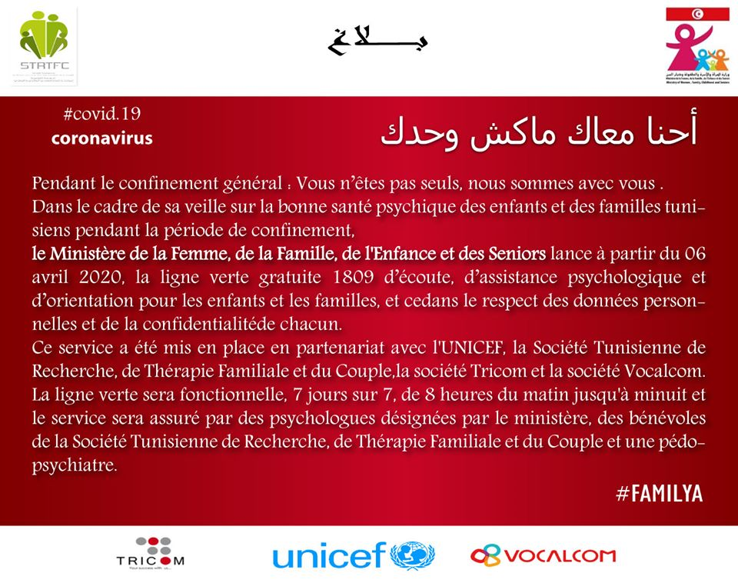

Turkey / Turquie

1- During the Covid-19 pandemic, all reports of abuse and exploitation against children can be addressed directly to the prosecution offices and law enforcement units, as well as to the 112 and 155 hotlines providing 24-hour uninterrupted service. In addition, "Women's Emergency Support Mobile Application" developed by the General Directorate of Security is another platform can be used for such purpose. On the other hand, children's divisions of the local police departments continue to operate round-the-clock in all provinces and in districts with a population of over 50,000. These denunciation mechanisms are announced to the public over social media.

2- "Alo 183" hotline of the Ministry of Family, Labour and Social Services continues to provide psychological, legal and economic support 24 hours a day for women and children who are at risk of violence, exploitation or abuse or who need support and/or assistance during the Covid-19 containment measures apply.

3- The Ministry of Family, Labour and Social Services has set up a "Covid-19 Psychological Support Line" consisting of psychologists, psychological counsellors and social workers to serve everyone in need, including foster families. About 14,000 people a week use this service, which operates round-the-clock in most cities.

4- A video entitled "14 Rules We Must Follow Against Covid-19" was prepared and shared on social media by the Ministry of Family, Labour and Social Services in sign language for hearing impaired children and adults. Link to the video:
https://ailevecalisma.gov.tr/tr-tr/haberler/bakanligimiz-isaret-dilinde-korona-virus-uyarilari/

5- A "Covid-19 Information Guide" was prepared by the Ministry of Family, Labour and Social Services to inform children under institutional care about the pandemic and to help them reduce their concerns. The guide regulates the measures to be taken in terms of child care institutions, adoption and foster family services and socio-economic support units, also includes an action plan for emergencies and is available at the following link:
https://ailevecalisma.gov.tr/media/42385/c-hgm-koronaviru-s-bilgendirme-doku-mani.pdf

6- Periodic health checks, psychological counselling support services and informative activities are organized for the children under institutional care and for those benefiting from family-oriented service models. In addition, children of proper age continue their education through the online network named "EBA" created by the Ministry of National Education.

7- Audio descriptions for visually impaired children have been added to all issues of the children's e-magazine "Sevgi Bir Kuş", published by the Ministry of Family, Labour and Social Services. In addition, all issues of the e-magazine have been translated into sign language for hearing impaired children. The issues of the e-journal, some of its content determined directly by a publication board consisting of children, can be found at the following link: http://www.sevgibirkus.com.tr/, Instagram: sevgibirkus, twitter: @sevgibirkus, facebook: Sevgi Bir Kus

8- A list of 427 books for children has been published by the Ministry of Family, Labour and Social Services, estimating that it will help those between the ages of 0-6 to spend productive time at home and positively affect their psychological state. The list is available at the following link: https://ailevecalisma.gov.tr/chgm/sayfalar/cocuk-dostu-kitap-listesi/

9- The Ministry of Family, Labour and Social Services has also published web links to culture, art and history museums and children's theatres to make the time spent at home efficient and pleasant. Through these web pages, museum visits can be made and children's plays can be watched online. To access these links:
https://ailevecalisma.gov.tr/chgm/sayfalar/cocuklar-icin-koronavirus-bilgilendirmesi/

Ukraine

No information submitted so far / Aucune information communiquée jusqu'à présent

United Kingdom / Royaume-Uni

No information submitted so far / Aucune information communiquée jusqu'à présent

INITIATIVES BY COMMITTEE OBSERVERS / INITIATIVES DES OBSERVATEURS AU COMITE

Hope for Children Cyprus / Hope for Children Chypre

To begin with, our Organisation realized a Press Conference that was exclusively addressed to children and youth on the occasion of the measures taken to prevent the spread of virus COVID-19. During the Conference, practical ideas and solutions were given on how children can face this situation for the upcoming period and helplines as well as online support chats were promoted.

Press Conference exclusively for Children and Youth about coronavirus :

“Hope For Children” CRC Policy Center realized a Press Conference today that was exclusively addressed to children and youth on the occasion of the measures taken to prevent the spread of virus COVID-19.

As adults, children’s daily routine has abruptly changed too. Children are forced to adjust to a new reality without being prepare for this change.

As it is provided by the Convention on the Rights of the Child (article 17), every child must have access to information and material that aims to promote their social, mental, moral, psychical and spiritual health. This information should be immediate and in an understandable language to the child, responding to their cognitive and developmental level.

During the Conference, practical ideas and solutions were given on how children can face this situation for the upcoming period. Knowledge is the tool and the power for children and their parents.

Opening the Conference, the Director of the Humanitarian Division, Ms Andria Neocleous referred to the measures taken by Hope For Children at this crucial period so that the Organization can continue to be next to the children who need help. She specifically mentioned: “We continue to provide therapeutical and support services to children victims of all forms of violence, we immediately respond to missing children cases and we provide support to foster parents. At the same time, our staff remains next to the unaccompanied children accommodated at the children’s shelters of the Organization and responds to the phone calls and messages coming from the online chat on a 24/7 basis”.

Ms Dialechti Chatzoudi, Coordinator of the Psychology Department, encouraged children to share unpleasant feelings that they may experience this period with people they trust. Also, once a day to be informed only from valid sources and with the assistance of their parents. At the same time, taking into consideration that under these circumstances, problems like violence against children continue occurring and may also increase, she stressed: “During this period we may use the internet and social media more in order to communicate with others. It is very important that we are careful for our safety, in order to avoid abusive behaviours, such as cyber bullying or breach of our personal data”.

Dr Michalis Angastiniotis, Paediatrician and former Director of the Paediatric Unit of Makarios Hospital, participated at the Press Conference and explained to the children the importance of the protection measures for both themselves and for those around them. In specific he mentioned “For a while, you will not be able to play with your friends as you did before… In order to protect yourselves it is important to keep around two meters distance even from the people you love.”, while he continued explaining practical measures that children can apply.

In his statement, the Director-General of Hope For Children Mr Joseph Borghese said: “We are in constant communication with all stakeholders such as the Ministry of Education and Culture, exploring ways of cooperation in order to strengthen the support towards all children”.

Every child’s health and access to medical care is one of their fundamental and basic rights, as it is established on article 24 of the UN Convection on the Rights of the Child. The state and society has to make sure that this right is not violated and that everyone is actively contributing to the application of this right in order to preserve not only the psychical, but the mental health of all children. “Hope For Children” CRC Policy Center helpline 22 103234 and the online chat at: www.uncrcpc.org.cy are available to all children and parents to give support and guidance on a 24hour basis.

Watch the Press Conference (in Cypriot): https://www.youtube.com/watch?v=e_Zc_HDRtQA

Furthermore, we grab the opportunity to also share with you our latest initiative to combat child sexual abuse and exploitation, which is the short film "Watch Over me", directed by Leah Kayaleh, written and financed by Leah Kayaleh and Rani Kayaleh. This film was given to us in order to sensitize the public on the nature of child sexual abuse.

https://www.youtube.com/watch?v=ZCSQN112gvw&fbclid=IwAR115XV2ZTmfPW07jMZKKllHUb5w9aSntJKX3GXwCfbSIENrapsfg_ASZ2I

eNASCO Belgium / eNASCO Belgique

Voici le lien vers les 2 campagnes réalisées en Flandre : https://f.io/C21iBkbZ, et celui de YouTube : https://www.youtube.com/watch?v=PLhfC-aUW5g

Nous lancerons bientôt une campagne similaire du côté francophone du pays.

EUROPOL

In relation to suggestion of Council of Europe and also from Lanzarote Committee secretariat, we are glad to contribute the information and initiatives that can serve as a better protection of all our children.

Since the outbreak of COVID-19 pandemic at Europol we prepared also several information for wider public. We did not forget also on the most vulnerable members of our society – children. Therefore, we are honoured to send the below listed materials and information. We added also iconographic in attachments.

The main source in relation to protect children is:

1. The subpage addressed as “COVID-19: CHILD SEXUAL EXPLOITATION” is available at: https://www.europol.europa.eu/covid-19/covid-19-child-sexual-exploitation

- Main topics covered are:
a) What is different during the COVID-19 pandemic?
b) What can I do as a parent?
c) What can I do as a carer/teacher?
d) How do I talk to children about being safe online?

- In this subpage we provided a guide, which we explained as following: The global impact of COVID-19 means young people will be spending more time at home — and more time online. There are lots of great ways children can use connected devices to learn and play, but there are also risks. As parents and carers, you have the best opportunity to support and guide your children to avoid online risks and have safer experiences. Governments and industry also have a role to play in making sure the online world is a safe place to be. And the guide is available at:
https://www.europol.europa.eu/sites/default/files/documents/global-parent-online-safety-advice-esafety-europol.pdf

2. Other available sources and information prepared by Europol are:

- child safety online:

- Overall online safety: home, (tele)workplace and children
https://www.europol.europa.eu/activities-services/public-awareness-and-prevention-guides/make-your-home-cyber-safe-stronghold
- Children drawing
https://www.europol.europa.eu/publications-documents/children-drawing
- Say No campaign (against sexual coercion and extortion)
https://www.europol.europa.eu/activities-services/public-awareness-and-revention-guides/online-sexual-coercion-and-extortion-crime

- Threats and trends in general in relation to COVID-19:

- Regularly updated and collected
https://www.europol.europa.eu/staying-safe-during-covid-19-what-you-need-to-know
- Europol’s report (for children safety see pages 7-9)
https://www.europol.europa.eu/publications-documents/catching-virus-cybercrime-disinformation-and-covid-19-pandemic

- Other topics:

- Last, but not least: Tips for safe teleworking
https://www.europol.europa.eu/activities-services/public-awareness-and-prevention-guides/safe-teleworking-tips-and-advice

In addition, Europol provided the report on Catching virus cybercrime, disinformation and COVID-19 pandemic, available at: https://www.europol.europa.eu/publications-documents/catching-virus-cybercrime-disinformation-and-covid-19-pandemic

There are plenty other informative materials for different crime areas and tips for different trends/threats, perhaps it would be worth to mention of their existence on Europol website: https://www.europol.europa.eu/

And at least, but not the last law enforcement community is active in protecting the children. Here are some of the recent PR releases by Europol:

- https://www.europol.europa.eu/newsroom/news/international-police-cooperation-leads-to-arrest-of-dark-web-child-sex-abuser-in-spain (released 21 April 2020),

- https://www.europol.europa.eu/newsroom/news/90-suspects-identified-in-major-online-child-sexual-abuse-operation (released 31 March 2020),

- https://www.europol.europa.eu/newsroom/news/dark-web-child-abuse-administrator-of-darkscandals-arrested-in-netherlands (released 12 March 2020).

Also, iconographic materials are added:

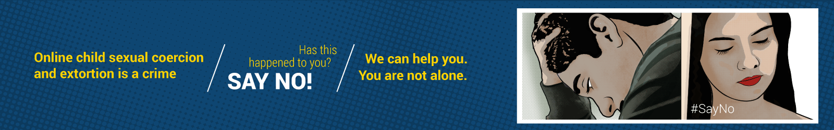

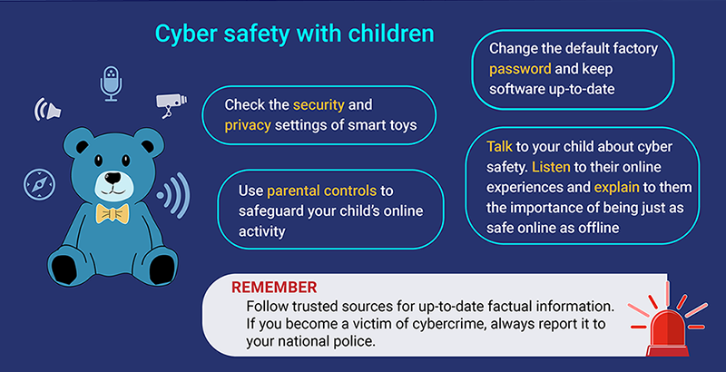

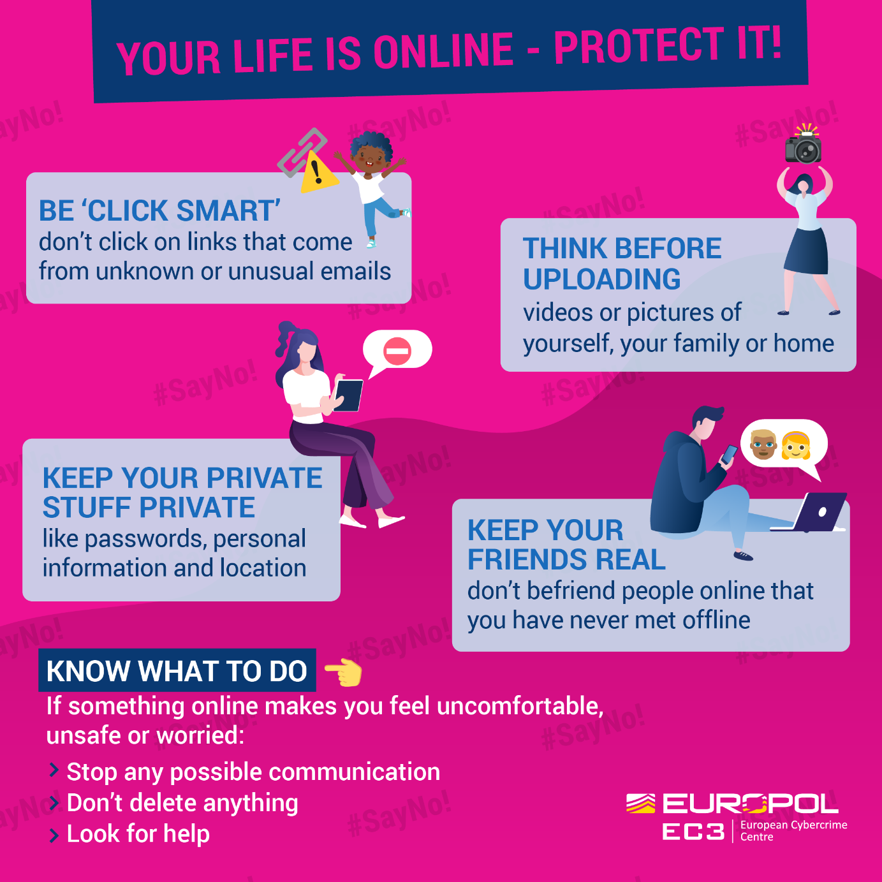

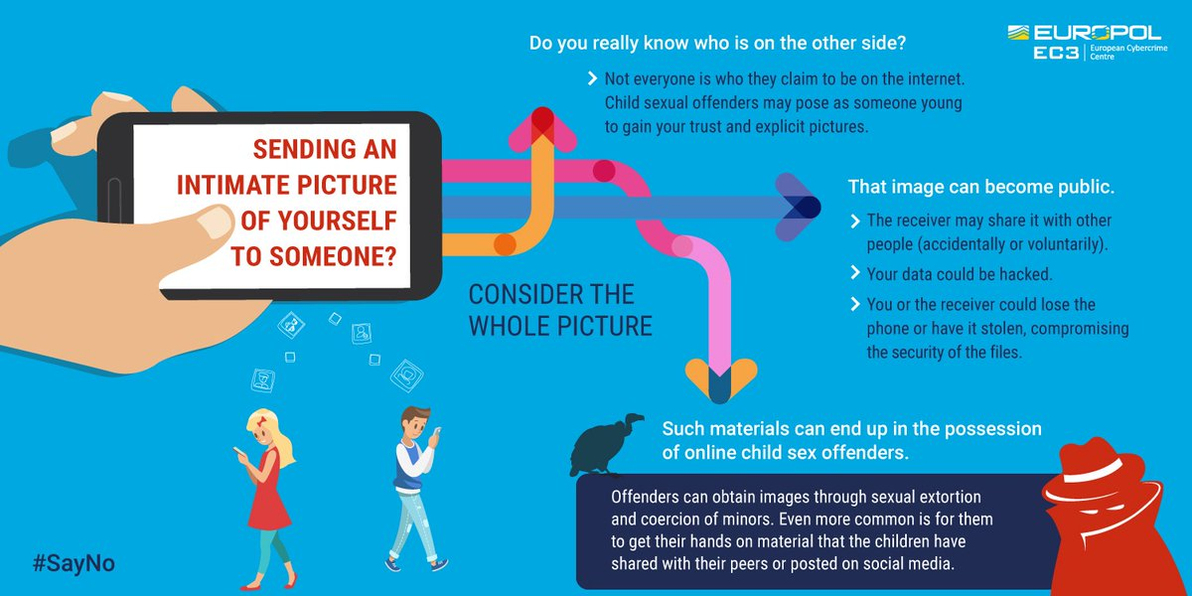

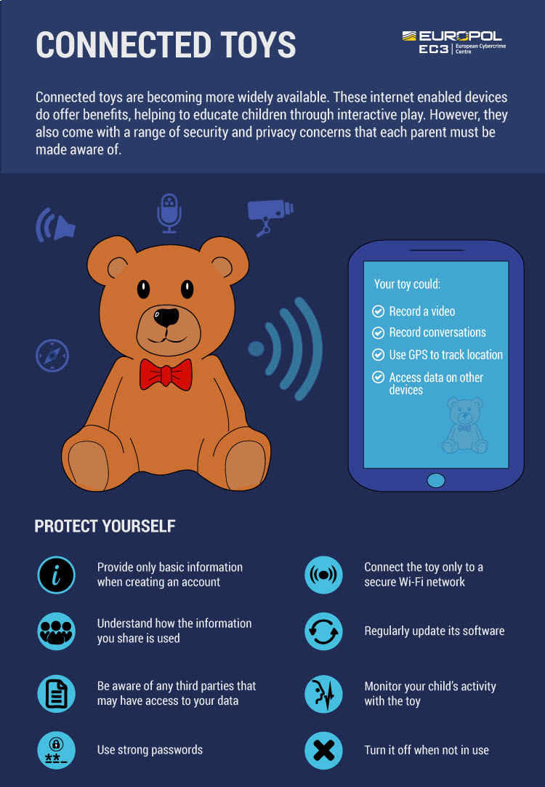

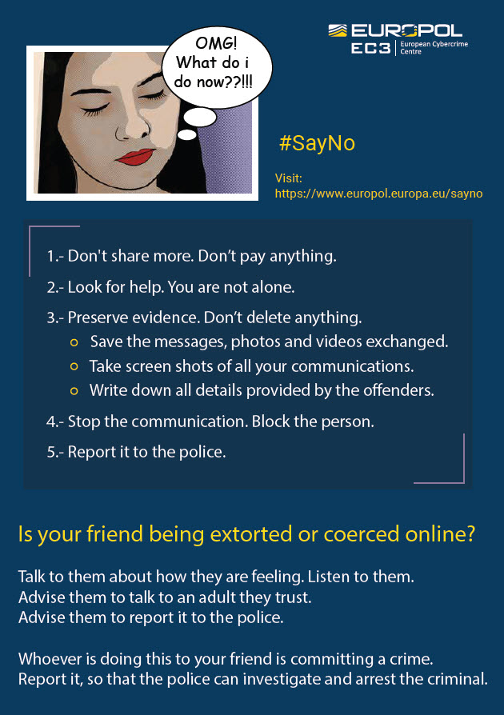

Missing Children Europe

Missing Children Europe Statement on
COVID-19 Protecting children (at risk of) going missing

The COVID-19 pandemic has a huge impact on individuals and societies, challenging us to adapt to new lifestyles, working conditions and social relationships. At the same time, the restrictive measures to limit the spread of the pandemic, have heightened the risks to which certain children are exposed. While fighting the virus that is shaking our society, we cannot neglect our responsibility and obligation to protect the most vulnerable among us.

116 000 HOTLINES or missing children play a crucial role in guaranteeing support and protection for missing children, children at risk of going missing and their families, especially in this critical moment. They are currently redoubling efforts to work remotely and ensure their services 24/7.

Get the PDF version here.

RUNAWAYS - Hotline operators notices lockdowns do not prevent children from running away. Isolation measures and lack of access to psychosocial services increase the risk of running away for children in already critical environments: children living in institutions and children in families with pre-existing elements of violence. Crisis measures trigger domestic and interpersonal abuse in more families and lead to reduced supervision and neglect from parents in others, with no peers, teachers or social workers around to notice. School closures and social distancing, for all these children, means losing contact with their sources of support. In this situation, access to helplines and to hotlines for children (at risk of) going missing is essential and potentially lifesaving.

PARENTAL ABDUCTIONS – The measures cause new cases of international child abductions, as some separated parents decided to move to another country with the children for the duration of the confinement. At the same time, the situation aggravates existing international family conflicts. For both new and existing cases, experts report slowdowns, deferrals and dismissals of judicial proceedings and return decisions. Border closures make it impossible to implement return decisions and bring the child back to the left-behind parent and country of origin, triggering feelings of stress, uncertainty and fear in the children involved. This intensifies the pressure on hotlines whose role is to support the left behind parent or to organise online mediation sessions.

CHILDREN IN MIGRATION - COVID-19 worsens the situation of children in migration, whether with their families, unaccompanied or separated, many of whom are neglected and live in poor and degrading conditions. Measures taken to curb the spreading of the virus sever their already limited access to support, legal aid and services. Many migrant children don’t have free and unrestricted access to health care, which is highly worrying during a global pandemic. Asylum procedures are suspended in some countries. Social distancing and isolation increase the risk of children to become separated from ill parents or caregivers. As a result, children in migration are now even more exposed to the risk of going missing, becoming victim of trafficking and exploitation, both sexual and labour. 116 000 hotlines are key players in making sure that all missing children cases are equally followed up, including when a missing child is a migrant child.
To support, protect and ensure that no one is left behind during these times, Missing Children Europe:
- Makes sure that the network of hotlines for missing children remains operational, keeping in touch with the members and remaining available to provide support where needed
- Carries out activities to support its members with the aim to improve the quality of the support provided both at national and international level
- Advocates for increased support from European Union, to make sure that all national hotlines remain available for free, 24/7, to all children and families in need including in these times of increased pressure.

HOTLINES FOR MISSING CHILDREN NEED NATIONAL GOVERNMENTS AND EUROPEAN DECISION MAKERS TO:

1. RESOURCE THE NATIONAL 116 000 HOTLINE TO FACE THE ONGOING EMERGENCY
In these days, with the lives and well-being of children are at risk, the EU and Member States should raise awareness on the crucial role of 116 000 hotlines, as well as support and ensure the availability and accessibility to this service 24/7, in each and every country where the hotline is operational.

2. ENSURE ACCESS TO CHILD PROTECTION SERVICES
Member States should ensure that child protection services remain open, available and accessible to children under these circumstances. To safeguard the health of child protection workers, they should adapt the services to remote work, through use of technology, phone, video calls and systems that guarantee contact between children and social workers.

3. PRIORITISE THE BEST INTERESTS OF THE CHILD
Closure of borders, travel restrictions and any other measure limiting free movement should be necessary, non-discriminatory and proportionate. Such restrictions should have the smallest impact and affect the implementation of return decisions in international child abduction cases at lowest; the best interest of the child principle should always prevail when implementing return decisions, including under current circumstances.

4. AVOID COMPROMISES ON CHILDREN’s RIGHTS
In order to protect children in migration, including those that fall outside protection systems, and to prevent them from going missing or becoming victims of abuse, Member States should speed up asylum procedures, engage in family tracing and reunification through cross-border cooperation, provide family-based alternative care for unaccompanied children and prevent separations from caregivers and parents. Member States should refrain from suspending the right to apply to international protection and should comply to their obligations under human rights, European and international law.

In addition, Missing Children Europe welcomes and supports ongoing campaigns for the relocation of unaccompanied children from Greece.

“Like our health workers, food supply chain workers and safety force, you [hotlines operators] are key to society.”
– Maud de Boer Buquicchio, President of Missing Children Europe

